Forces are everywhere

1 Which forces are pushes and which ones are pulls?

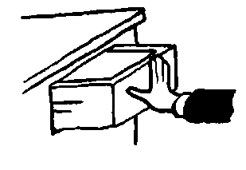 | 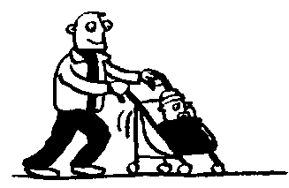 | 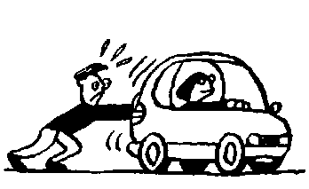 | 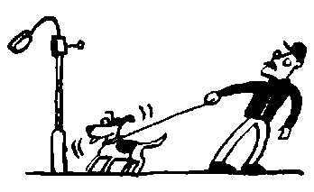
Push or pull

Push or pull

Push or pull

Push or pull

2 Look at the pictures below. Choose words from the box below and write the names of the forces next to the arrows.

A | 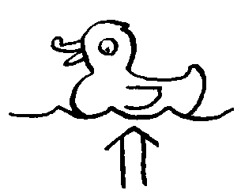  _____________ | B | 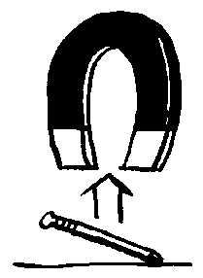  _____________ | C | 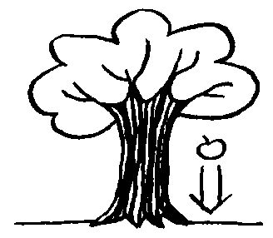  _____________
D |   _____________ | E |   _____________ | F | 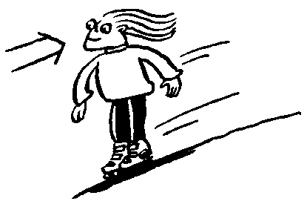  _____________

Gravity Static Friction Upthrust Magnetic Air resistance

